

|  |  |
| --- | --- |
|  | Lab 6 |
|  |  |
|  | Akshar Panchani 202101522  CT303 Digital Communication  11/13/23 |

**Experiment -1**

**CH 1: DATA CLK (266 KHz) & CH 2: SERIAL DATA (00011011)**

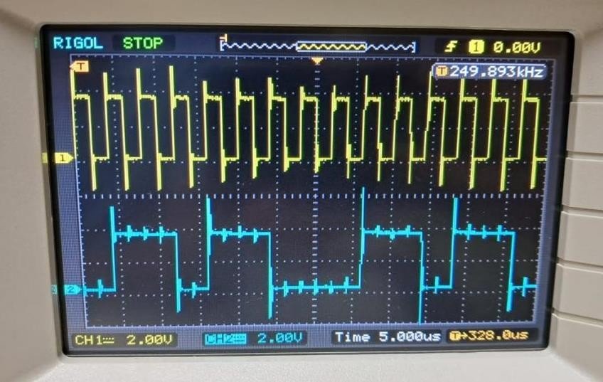

**CH 1:DATA IN& CH 2:NRZ-L & CH 2: NRZ-M**

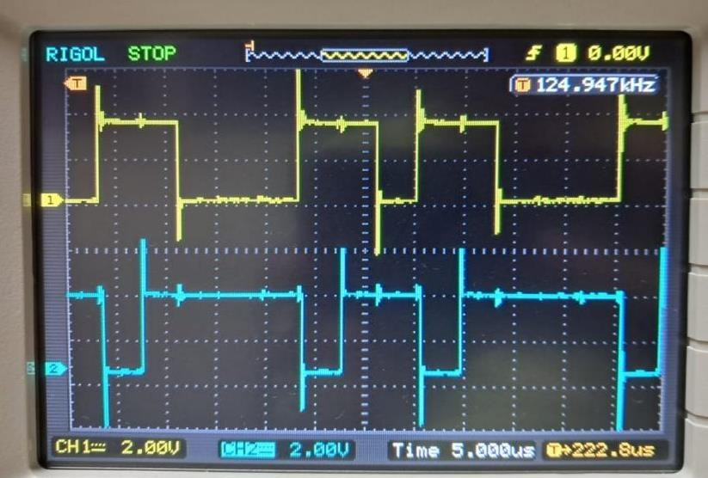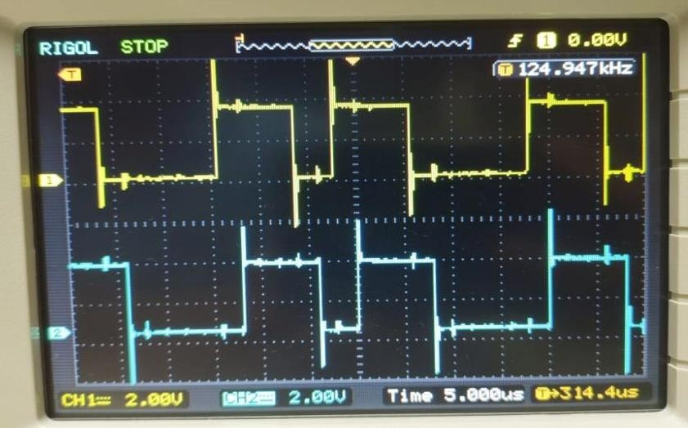

**CH 1: DATA IN& CH 2: NRZ-S**

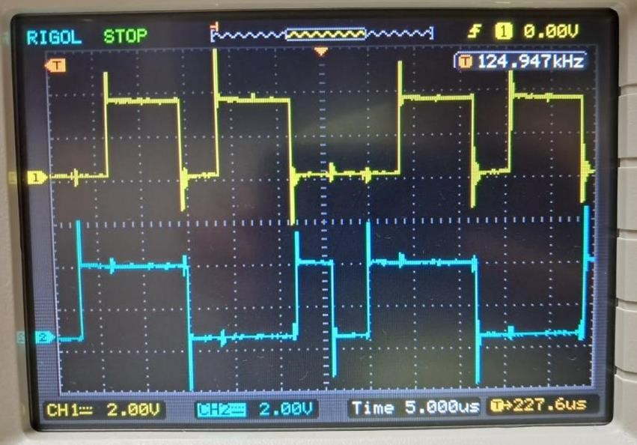

**CH 1:DATA IN& CH 2: OUT1 & CH 2: OUT2**

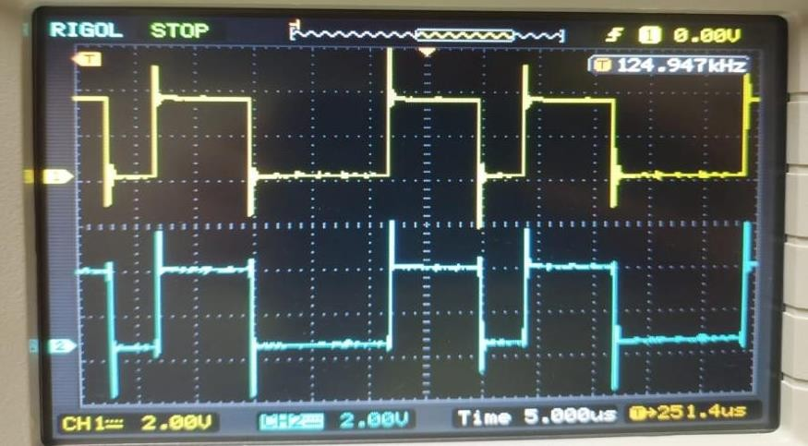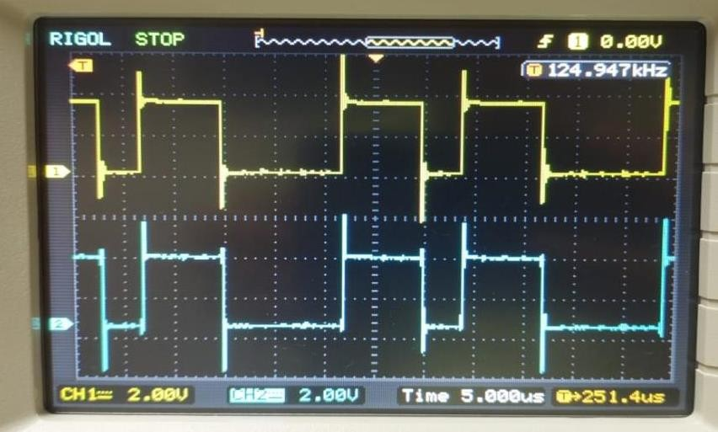

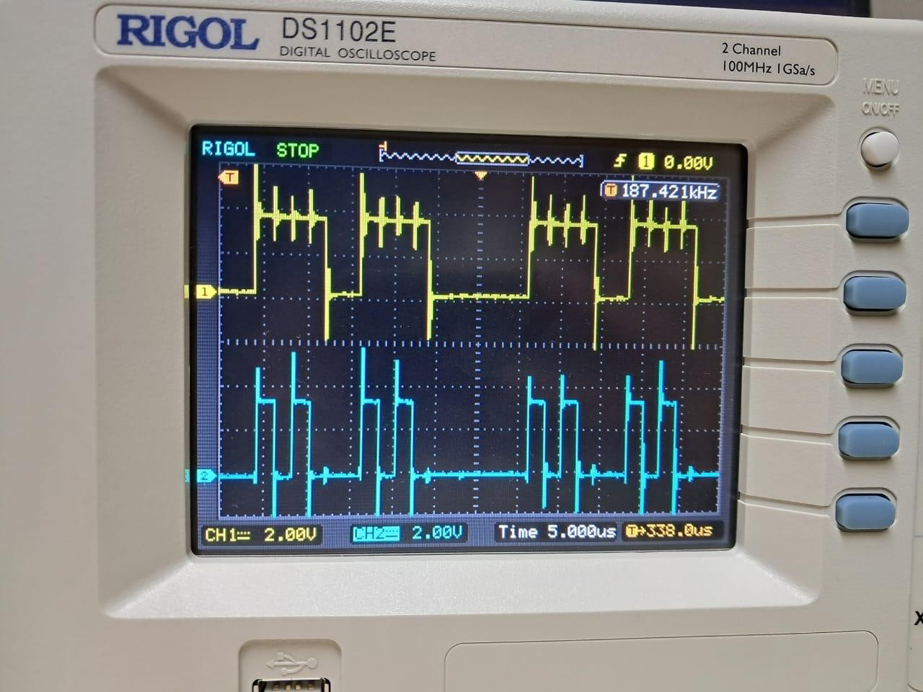

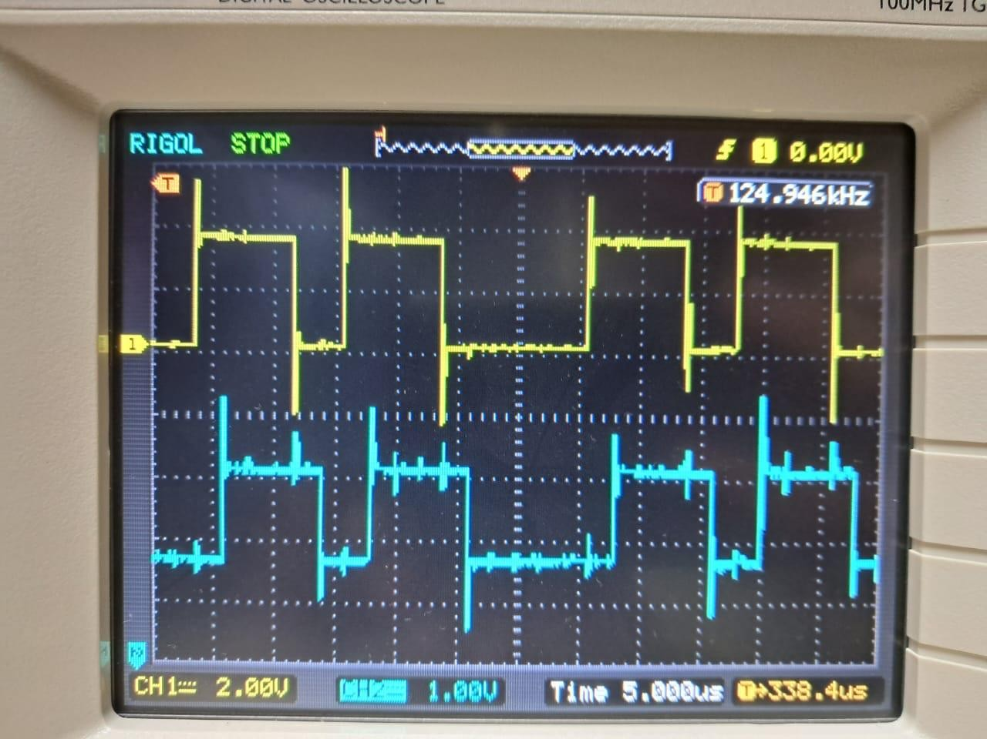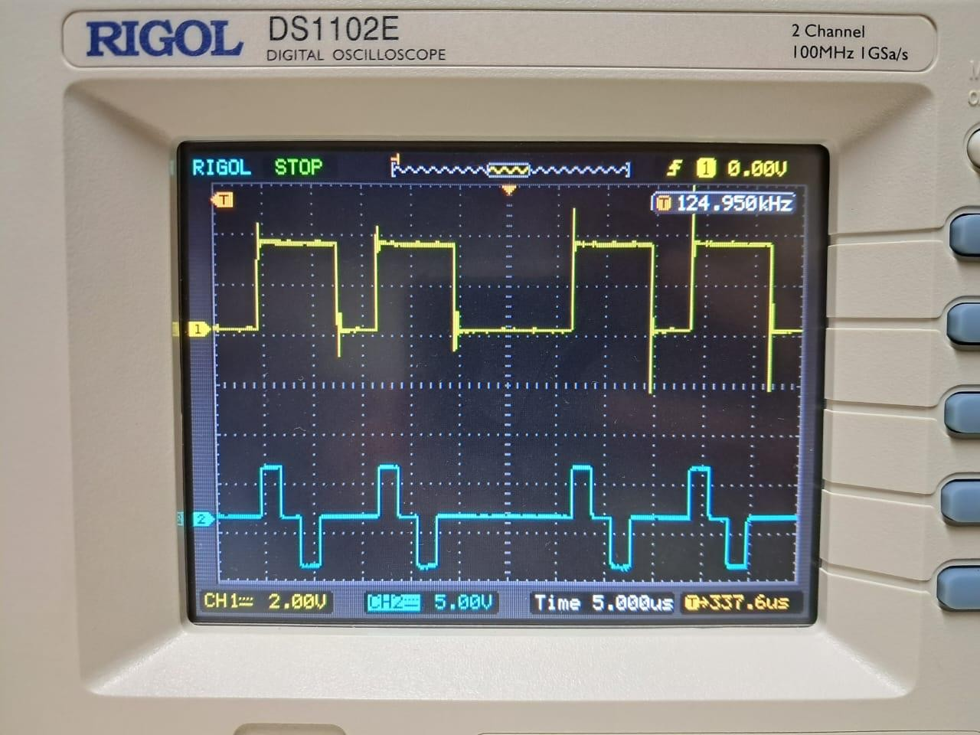

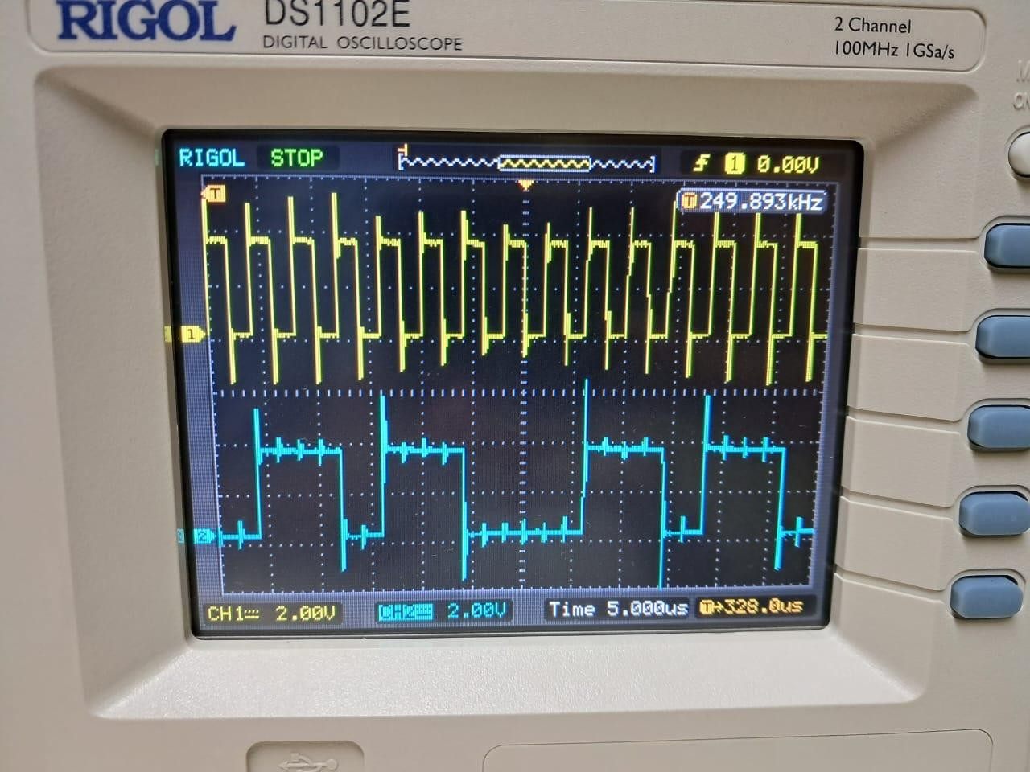

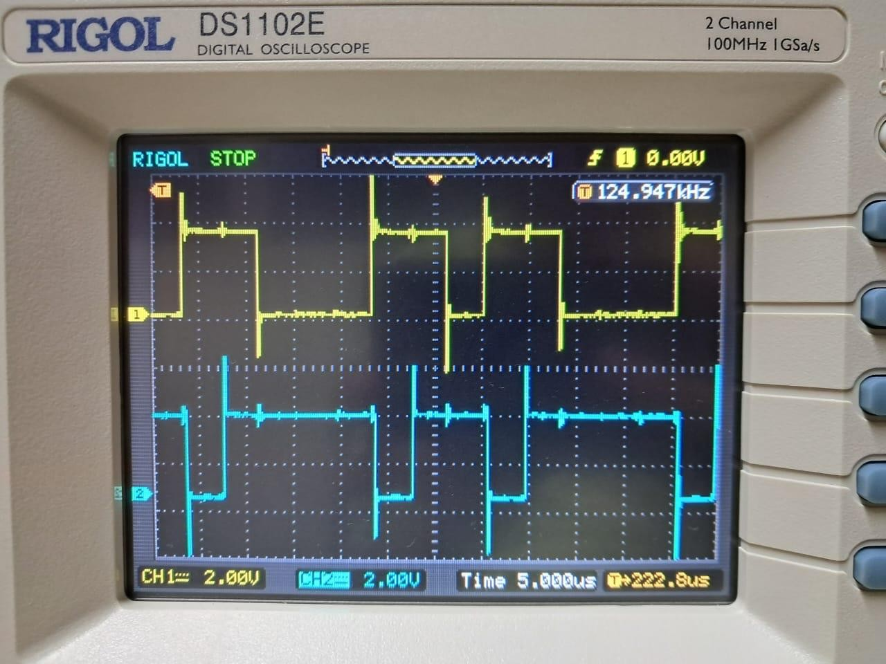

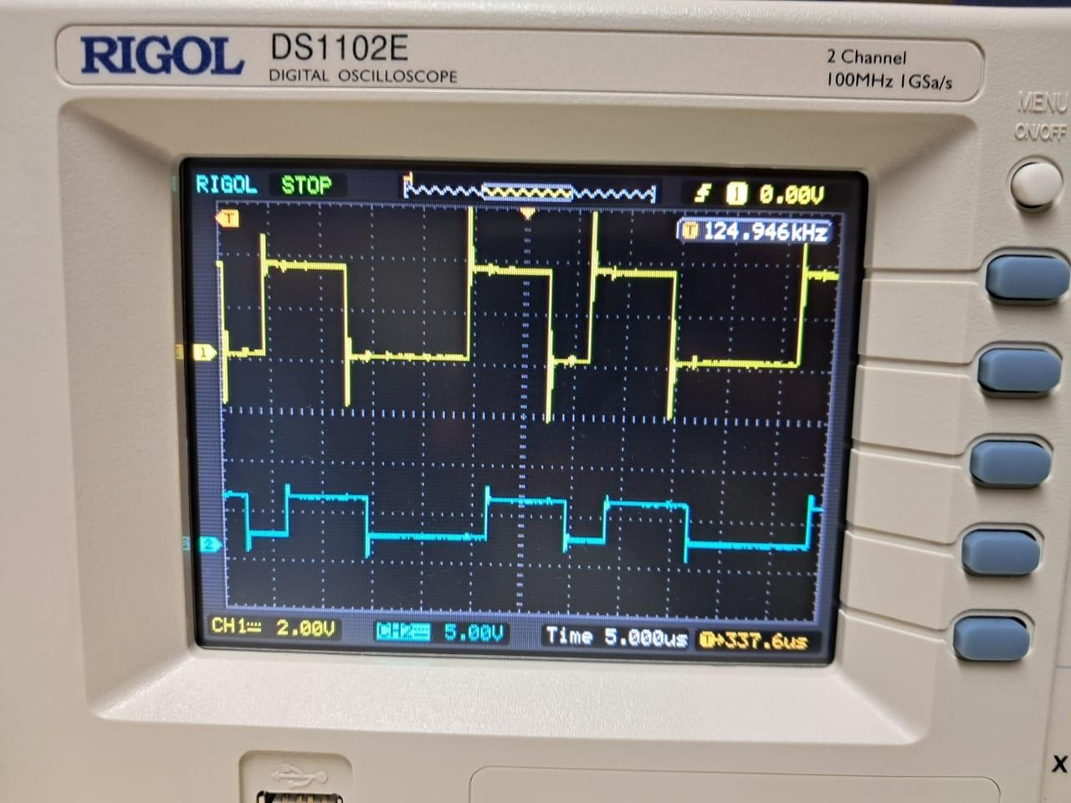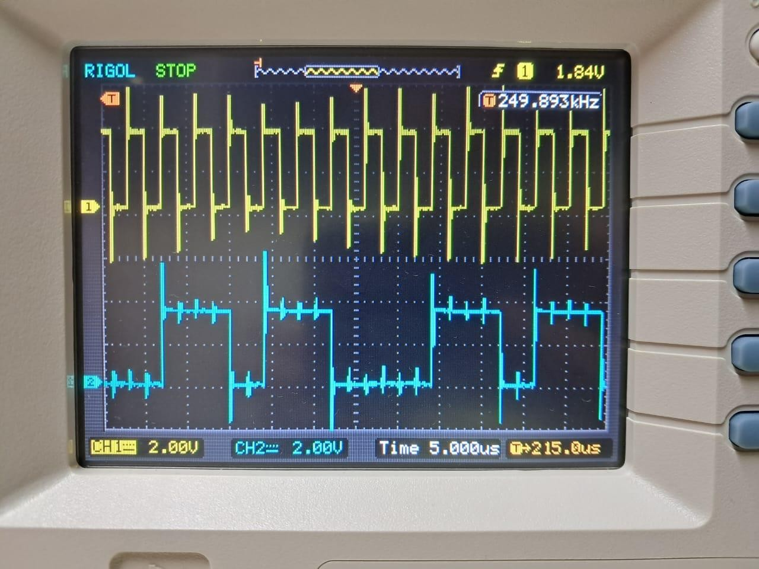

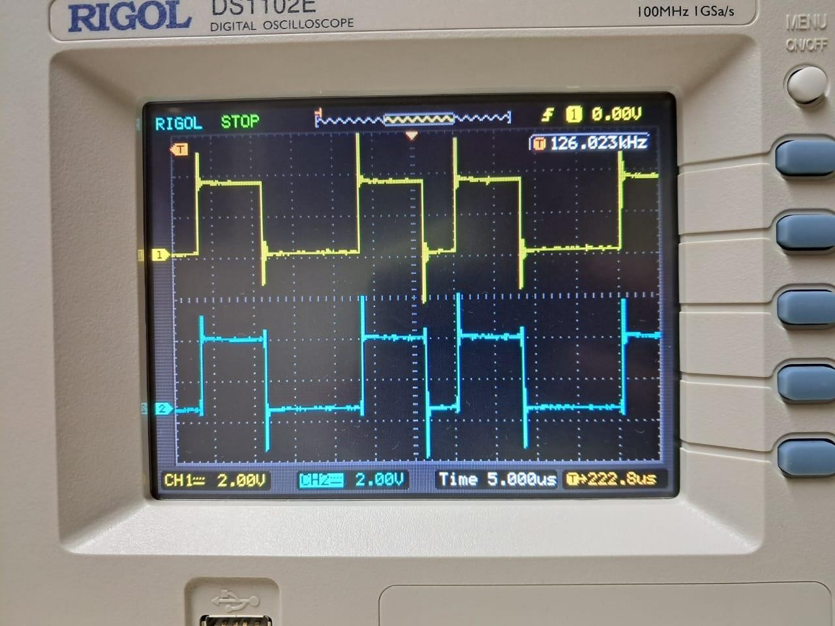

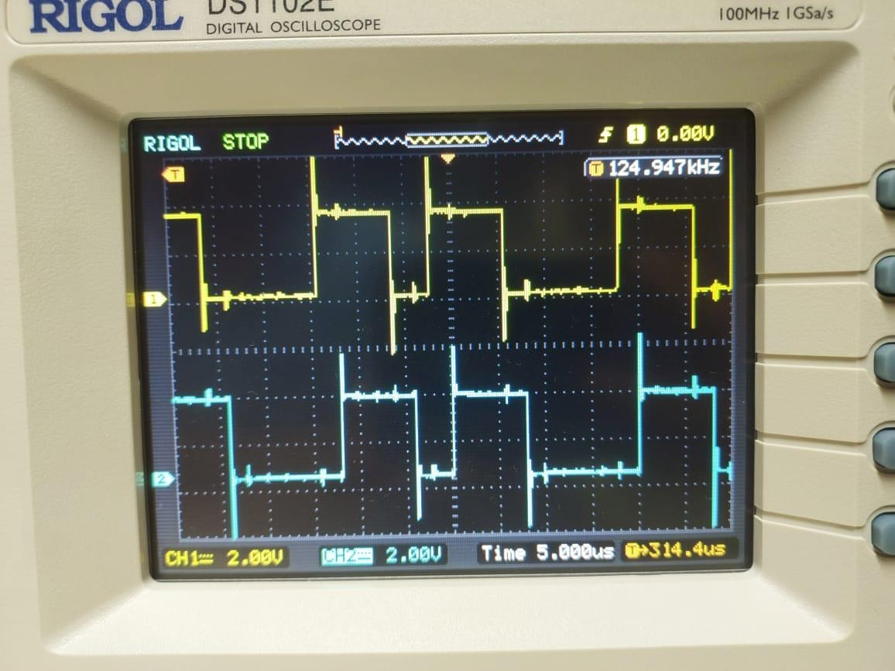

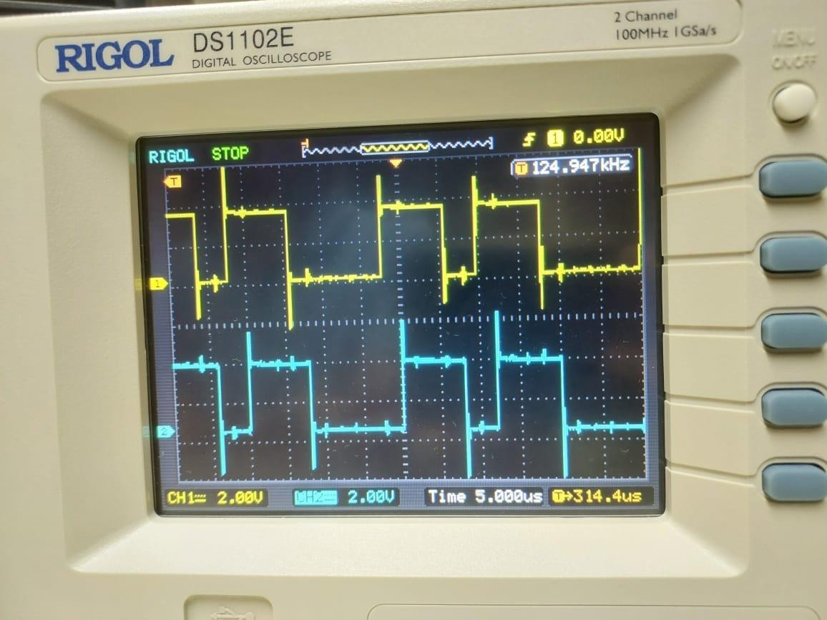

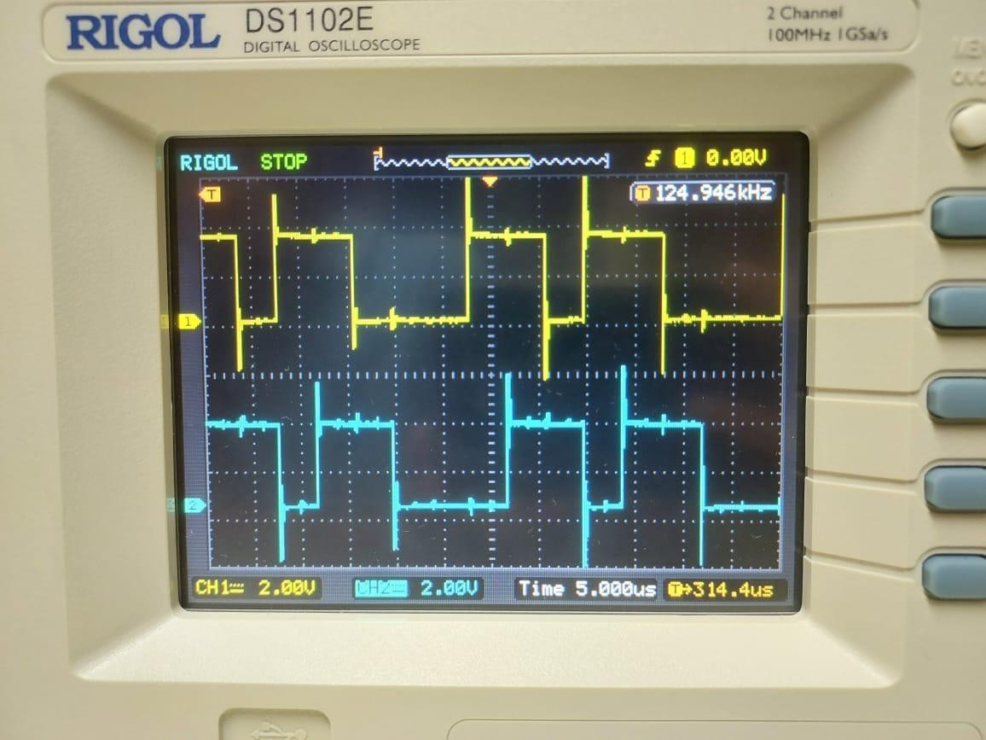

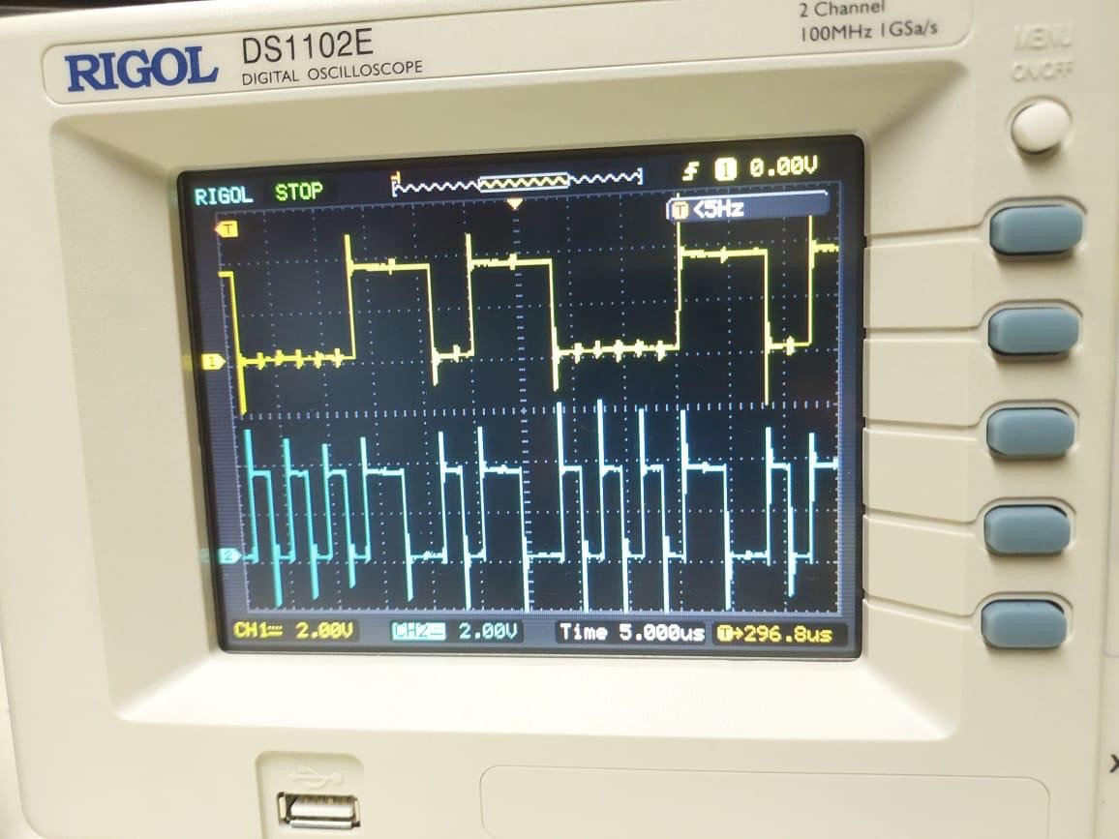

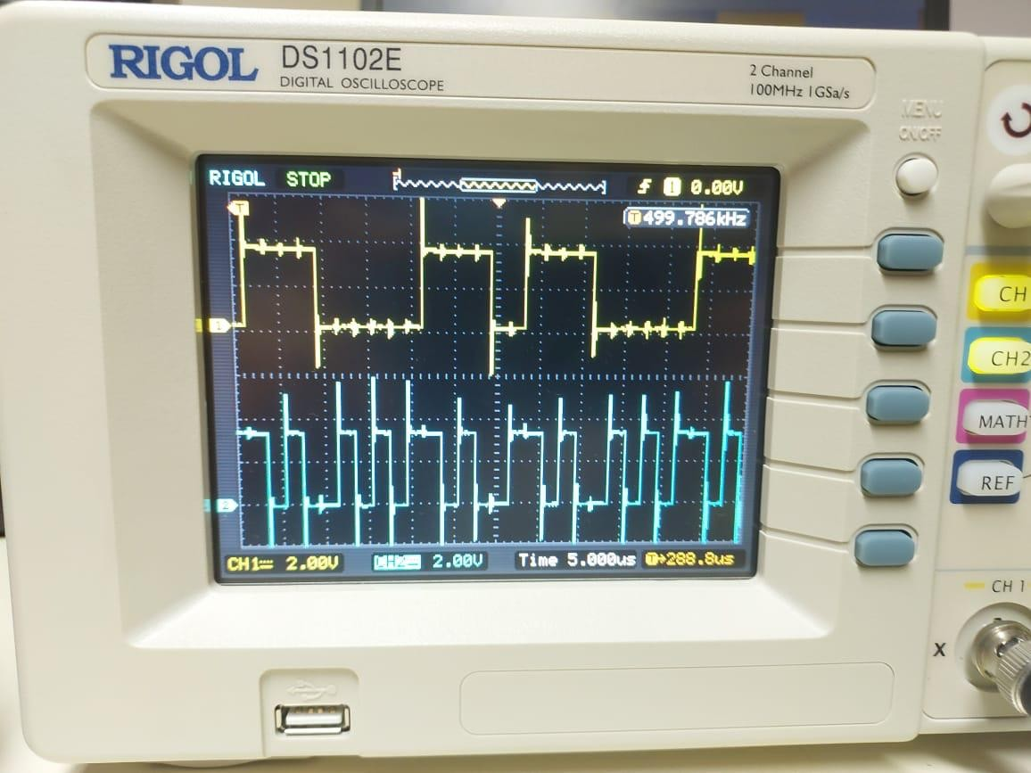

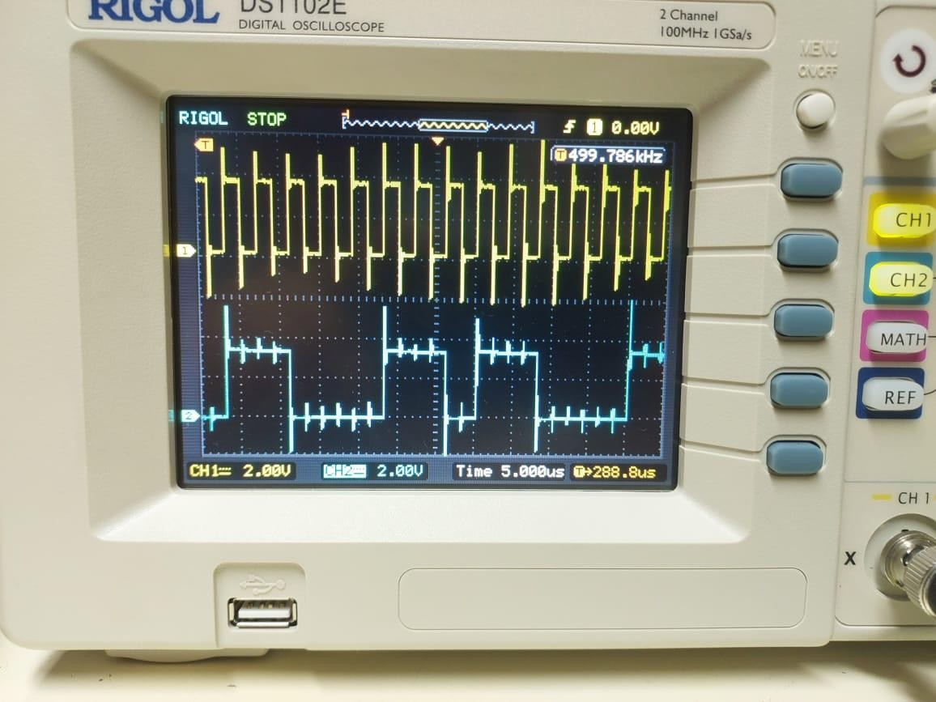

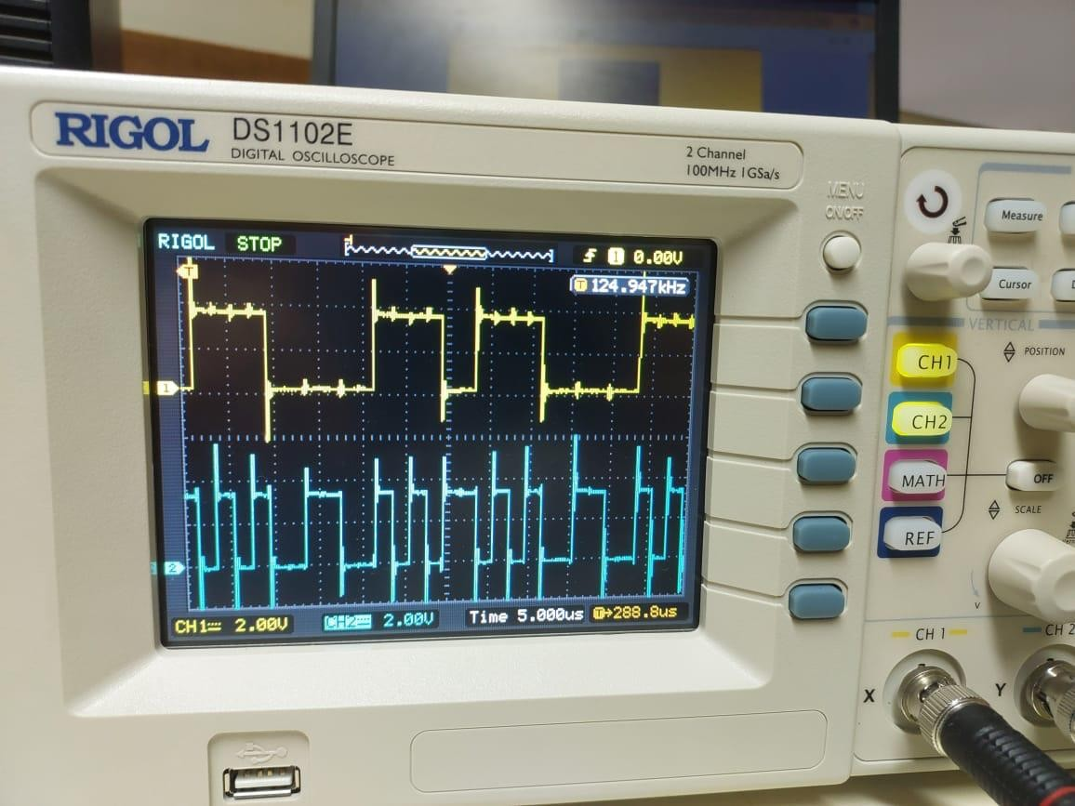

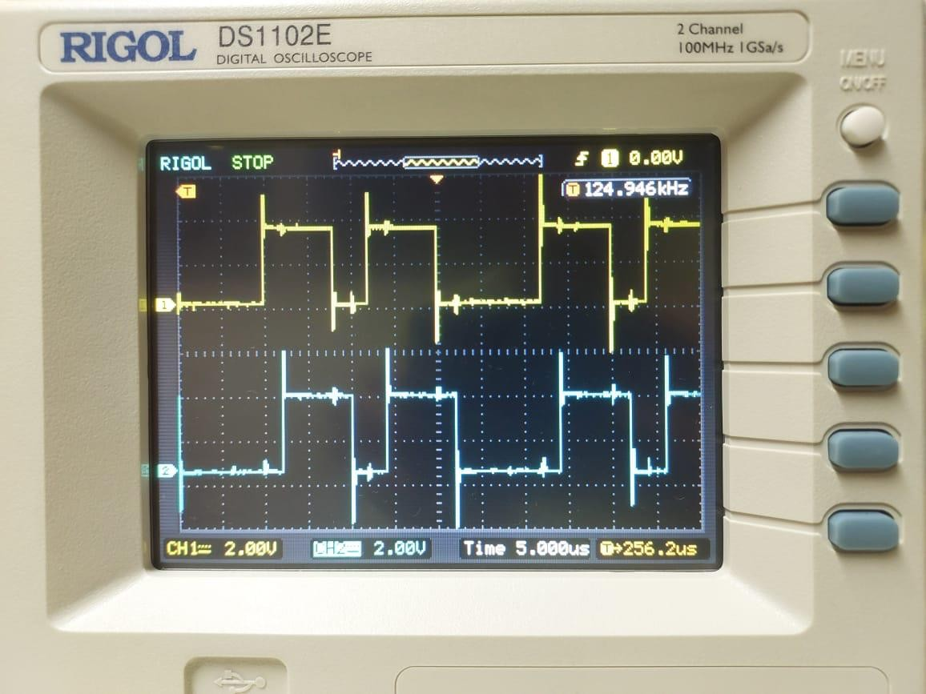

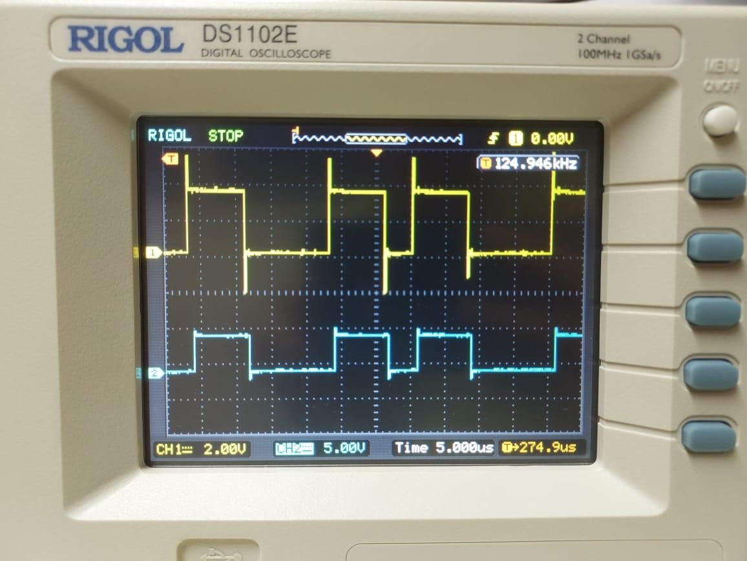

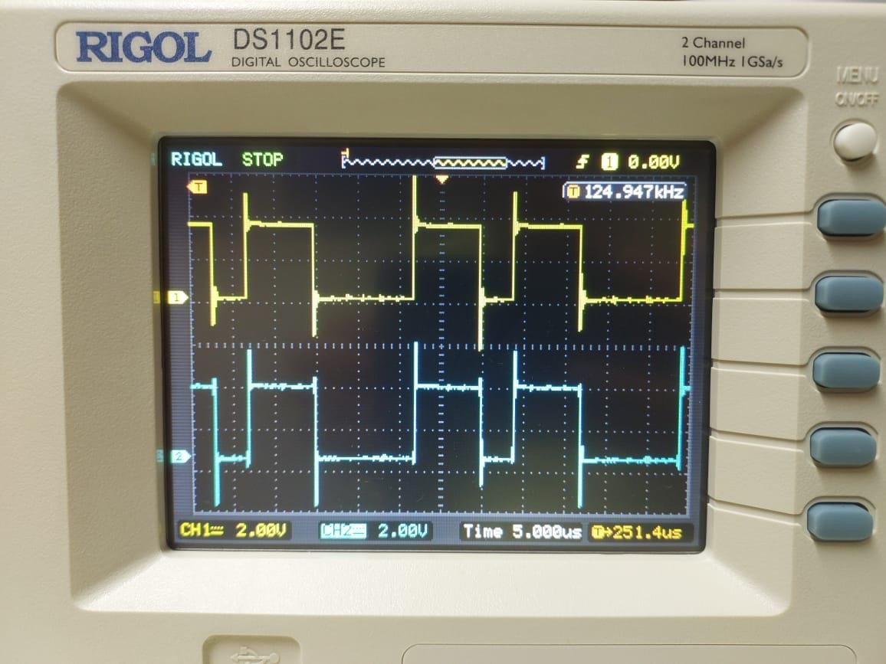

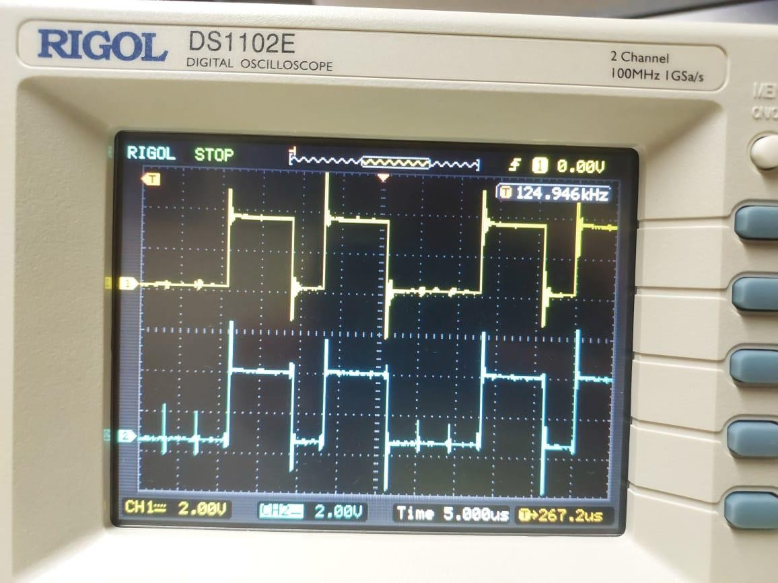

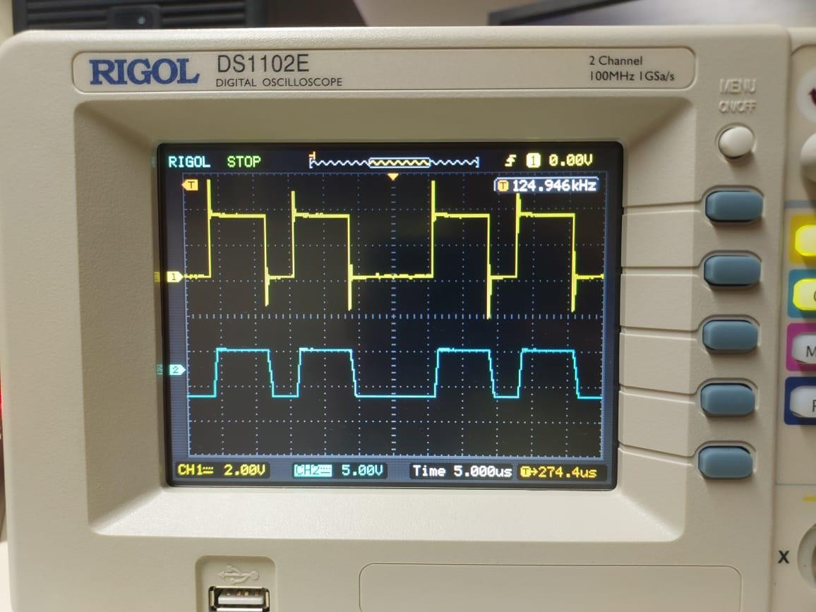

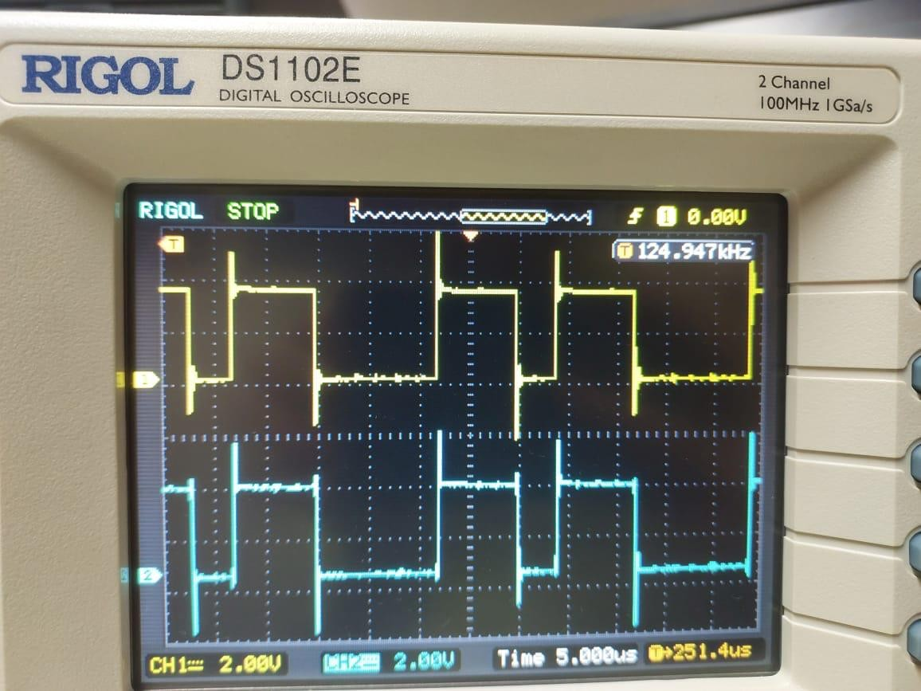

# Question 6.8:

N = 10000; % Number of bits

data = 2*randi([0,1], 1, N) - 1; % Generating random data: +1 or -1

h = [0.5, 0.5]; % This is an assumption.

% Variance values

sig_values = [0, 0.1, 0.2, 0.5, 1.0];

for sigma =sig_values

received_data = filter(h,1,data);

noisy_received_data = received_data + sigma * randn(1, N);

% Decision Making: Assuming zero threshold. This might need to change based on your actual channel.

decoded_data = sign(noisy_received_data);

% Calculating error

error = sum(data ~= decoded_data);

err_rate = error/N;

fprintf('Rate of the error in sigma = %f is: %.4f\n', sigma, err_rate);

end;

Rate of the error in sigma = 0.000000 is: 0.5061  
Rate of the error in sigma = 0.100000 is: 0.2571  
Rate of the error in sigma = 0.200000 is: 0.2497  
Rate of the error in sigma = 0.500000 is: 0.2702  
Rate of the error in sigma = 1.000000 is: 0.3357

# Question 6.9

h_new = [1, 0.25];

% Using the same data and sigma values from 6.8:

for sig = sigma_values

received_data_new = filter(h_new, 1, data);

noisy_data_new = received_data_new + sig * randn(1, N);

decoded_data_new = sign(noisy_data_new);

err_new = sum(data ~= decoded_data_new);

err_rate_new = err_new/N;

fprintf('Rate of Error in sigma = %.4f for new channel = %.4f\n', sig, err_rate_new);

end

Rate of Error in sigma = 0.0000 for new channel = 0.0000  
Rate of Error in sigma = 0.1000 for new channel = 0.0000  
Rate of Error in sigma = 0.2000 for new channel = 0.0000  
Rate of Error in sigma = 0.5000 for new channel = 0.0382  
Rate of Error in sigma = 1.0000 for new channel = 0.1657

% For 6.9, it seems we have a different channel h_new = [1, 0.25]; % As described in the problem

% Using the same data and sigma values from 6.8:

for sigma = sigma_values

% Passing data through new channel with AWGN noise received_data_new = filter(h_new, 1, data); noisy_received_data_new = received_data_new + sigma * randn(1, N);

% Decision Making: Assuming zero threshold. This might need to change based on your actual channel.

decoded_data_new = sign(noisy_received_data_new);

% Calculating error for new channel error_new = sum(data ~= decoded_data_new); error_rate_new = error_new/N;